All I have needed Thy hand hath
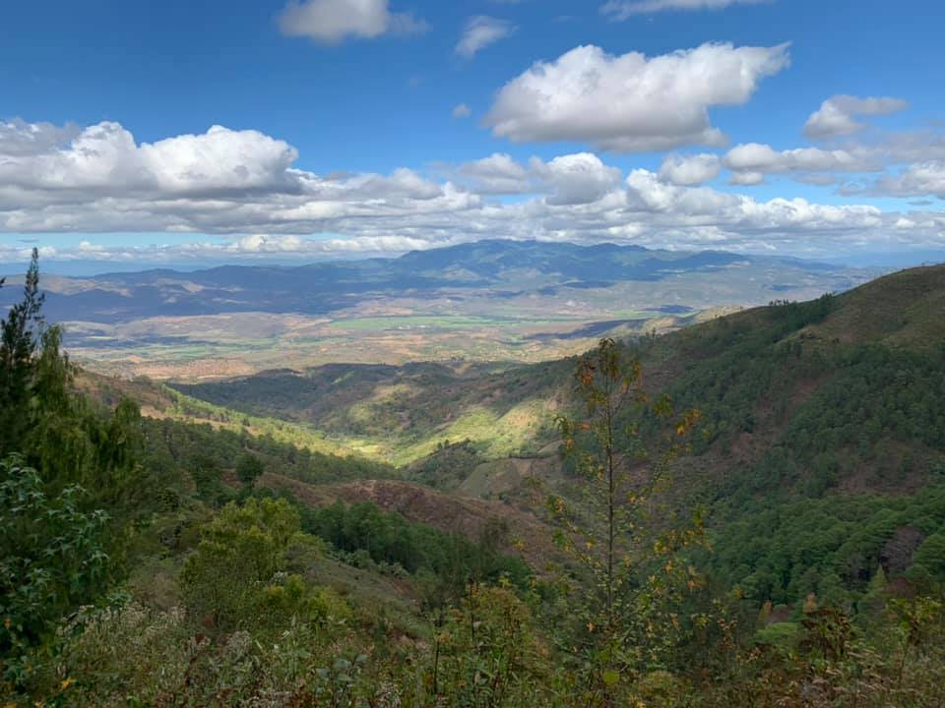  A.A.R.O.N.S Mission Outreach  The AMOR Handbook | A Guide to Ministering with Aaron’s Mission Outreach  Contents Include:  - Ranch Rules & Tips  - Being Culturally Considerate While in Honduras  - Safety in Honduras  Updated: 03/03/2026

provided—“Great is Thy faithfulness,”
Lord, unto me!
Ranch Rules and Tips

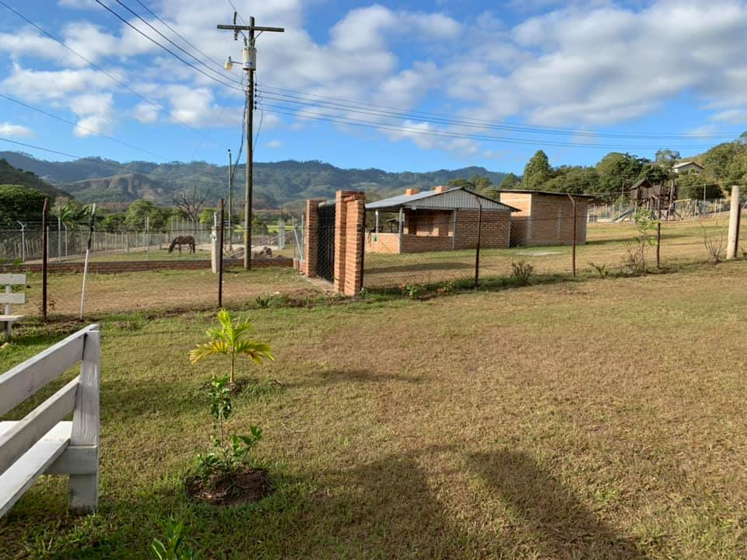
- Do not flush toilet paper or hygienic products down the commodes. The plumbing in Honduras is not fit to flush anything but waste.

- Bring or buy your own toilet paper, personal hygiene products, hand sanitizer, laundry detergent, and other household items. We are not able to provides these items for you currently.

- Do not drink or brush your teeth with faucet water. Clean water will be provided for you.

- Keep Freedom Ranch a smoke-free and alcohol-free facility.

- The showers will only be warm if the switcher on the shower heads are slid to the fully, shaded oval, and kept at a low-level pressure. When getting out of the shower do with caution the tile can be slick.

- Do not play music at high volumes. Noises can be heard throughout the Ranch. This can be disturbance to other missionaries who are trying to rest. We also request that you avoid listening to secular music while staying with us.

- Quiet hours are from 9:00pm to 7:00am. You may fellowship past these times as much as you like but please be respectful with your volume.

- Ever and Gladis, have an apartment and porch that are separate from the rest of Freedom Ranch. Please, allow them privacy unless you are invited into their homes or if there is an emergency. There are hammocks and chairs provided for temporary missionaries in the center portion of the front porch.

- Do not leave Freedom Ranch grounds without being in the company of two or more other people. Banditos (robbers) are always on the lookout for easy targets. For safety purposes, ALWAYS notify a staff member of your plans.

- Carry your passport anytime you leave Freedom Ranch property.

- Please turn off all lights and electronic equipment when you leave the ranch. This helps the mission cut back on their operating costs.
- Due to increase in Honduras, AMOR would like to suggest $45.00 per night, per person (beginning in the year 2023) for housing temporary missionaries. Naturally, this costs more for the mission. If you would like to donate extra funds to help support the mission as we house missionary groups, we would be extremely thankful! Your donations will help us from having to raise our rates in the future.

- Following outdoor activities all team members should help clean up and place all games and chairs back into their original home. If you are unsure of where something goes, please as AMOR staff.

- Even though we appreciate all donations we ask that teams do not bring XL t-shirts and large shoes/flip flops. Due to most Hondurans being small these are things that we are can no use for the people so please do not bring them.

- Donating clothing is always much appreciated and much needed. It is our hope that all donations are thoughtfully given with no stains, tears, and freshly washed. If you are donating personal items before your departure, please make sure everything has been washed and folded and ready for the staff to distribute as needed.

- The doctors always appreciate when there is new medicine brought to them, but we cannot accept any medicine or medical supplies that are expired. This is Honduran law not only can we get in trouble as a clinic for having it if you get caught with it coming into the country you can also get in trouble so we ask that you check all medicine dates and medical supplies before bringing them to Honduras with you

- Please bring new bills when you come, especially 100.00 bills when coming to the country. The banks will not except old bills.

- Please try to get food and supplies and things that you need when you arrive, or plan on going to town in the mornings and evenings when Ever takes the kids to and from school. This will save a lot of time and you won’t interfere with plans that have been made.

- When bringing new items into Honduras please take off the price tags and remove all new items from boxes to avoid paying taxes at customs.

- Don’t have your phone out in public to avoid theft.

- Please do not give money out until you talk to the missionaries. It is hard for Hondurans to cash American Money and if you give money to a child the parents will be the ones to receive it. The missionaries know the folks that need to be blessed and the ones who will misuse it.

- Talanga now has a supermarket, and you should be able to buy all the things you need there.

- There are restaurants that Americans can eat.

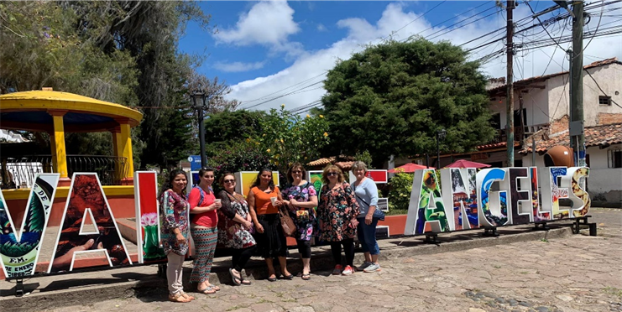

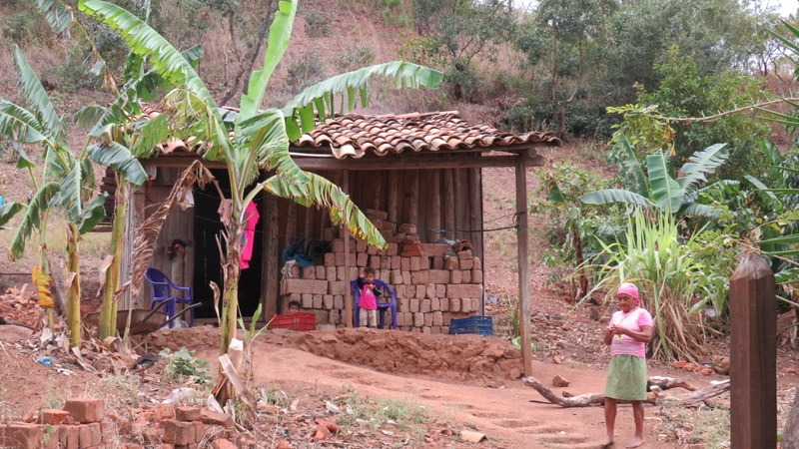
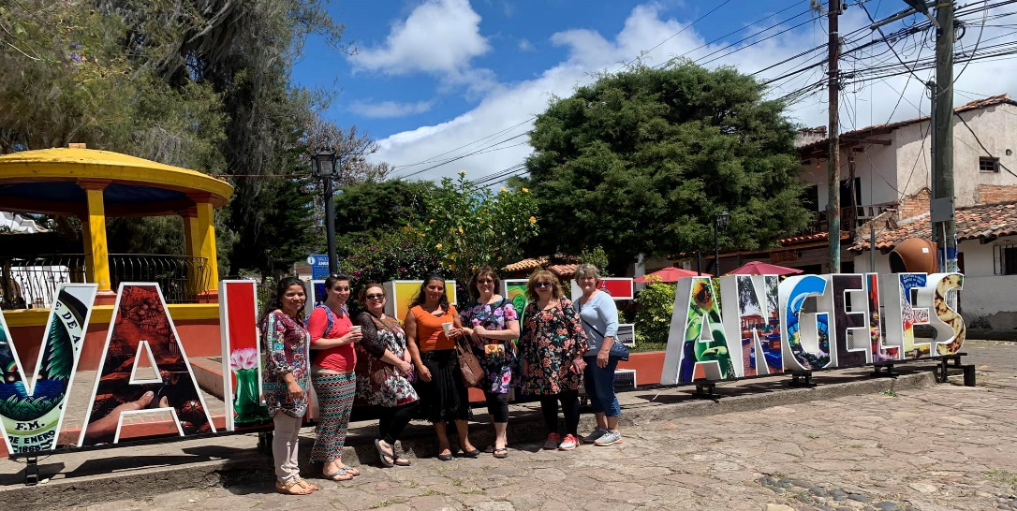
Being Culturally Considerate Much of Honduras is adapted to American culture. Most purchasable products or store signs include the English translation of the subject. Also, since more children are being sent to school by our faithful supporters, many of the people can speak and understand enough English to communicate general ideas. However, there are still many cultural differences between America and Honduras. We asked for the advice of several Hondurans concerning what Americans should be aware of when entering the Honduras culture, and how Americans should respond to different social situations. Keep in mind that Americans are generally well thought of. Americans appear as friendly to Honduran people. They are viewed as being very wealthy.

Eye-contact In America:
It is considered common courtesy to look someone in the eye for prolonged periods of time between different sexes. This shows that you are attentive to what they are saying, and that you are being considerate of them. This does not always mean that you have romantic interest in them. Also, prolonged eye contact can be rude and awkward in America.
In Honduras, eye-contact between different sexes mean something much deeper. Eye-contact is seen as an exchange of romantic and sexual interest, even when there is an extreme difference in age. Adding a smile to eye-contact confirms your interest. More specifically, Honduran men will try and force eye-contact with women to see if women are interested in them.
What Should You Do?
- Be careful and considerate of Honduras culture when making eye-contact. If you are a woman, you may find yourself being starred at a lot. The best tactic is to make brief eye-contact or ignore the starring altogether. If you are a man, remember that your eye-contact or friendly behavior can lead girls, even incredibly young girls, into thinking you want something more from them than friendship.

Nakedness in America:
In America it may be viewed improper for a mother to breastfeed her child while uncovered in a public place. It is improper for woman to show off her entire breast, and it can be seen as poor parenting to let a child run naked in public.
In Honduras, it is openly acceptable for women to breastfeed uncovered and in public, and it is not an unusual sight. It is a normal routine. Also, young children regularly run and play naked near their homes.
What Should You Do?
- You are guaranteed to see one or all of these mentioned sights while in Honduras. Remember that in this culture it is part of everyday life. Be polite and considerate to the Honduran people. Do not call extra attention to these sights. Politely smile and look away to give them privacy.

Tattoos:
In America, opinions on tattoos vary. Some see tattoos as wrong, other see tattoos as body art. Some people get tattoos to convey good messages to other people or to remember extraordinary events in their lives. Sometimes, tattoos are used as a confession of faith in Jesus Christ. Special tattoos might be associated with gangs, but the majority of tattoos do not imply an affiliation with a particular group.
In Honduras, tattoos are used to represent the affiliation with, or status within, a gang. The content of the tattoo is irrelevant. It is the act of having a tattoo that has meaning. Gangs are a serious problem in Honduras. Slightly offending a gang member could mean, not only your death, but the death of your family—children and infants included. Ex- gang members who have continue to wear the mark of murderer on their body. They conceal their tattoos as best they can or burn their tattoos off in order to hide their past.
What Should You Do?
- As stated above we at AMOR know that tattoos can have many different meanings. We ask that you try to conceal your tattoos as much as possible. We know that this is not always an easy task and if a tattoo is in a difficult place to conceal do not be in fear over it. We ask that you just do not draw attention to your tattoo and if a Honduran were to ask you about you tattoo simply explain what it means to you.

Piercings:
In America, piercings are viewed much like tattoos. Certain piercings are morally acceptable to some people while others are not. The motives behind certain piercings very from person-to-person
In Honduras, particularly in the churches and schools AMOR works with, piercings other than of the ears are frowned upon. The Honduran people take to heart the scripture in 1 Corinthians 6:19, “Or do you not know that your body is a temple of the Holy Spirit who is in you, whom you have from God, and that you are not you own?”
What Should You Do?
- Conceal or remove all piercings other than ear piercings. A person’s testimony is slightly discredited to the Honduran people when they see that he has disrespected the temple of God, or that they are purposefully drawing attention to sexual areas of the body. Please be considerate of the Honduran people.
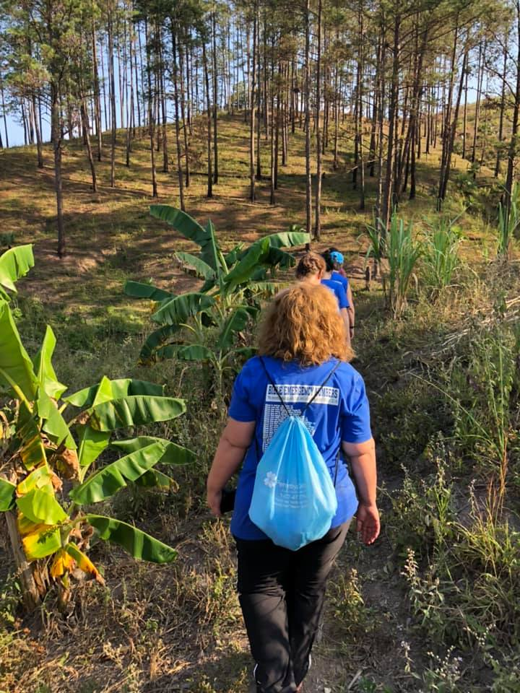
Clothing:
In both America and in Honduras, what a person chooses to wear (or not wear) has a greater effect on other people than is given credit. What an Americans wear in Honduras is even more powerful considering the influence that Americans have as Christians on the mission field. Wearing clothes that are too revealing, not only speaks ill of the wearer, but is a distraction to members of the opposite sex. We DO NOT wear shorts to church services, and we DO NOT wear short skirts or short shirts in the Ranch or on the mission field.
What Should You Do?
- At Aaron’s Mission, we understand that the tropical climate is sometimes difficult to brave in jeans and t-shirts. We understand the discomfort of heat, but we ask all our missionaries to wear light breathable clothes that fully cover the following areas: Chest, thighs abdominal regions, and backsides. No cleavage, mid-rises, backsides. Also, your shorts should be no more than two inches above your knee. We also ask that clothes are loose and easy to work in.
*If you do not wear clothes that suit these standards, you will be asked to change.

Staying Safe in Honduras
Most missionaries’ find that working with AMOR is a fantastic and fun-filled experience. Even so, there are still many dangers and pitfalls we would like you to be aware of before your stay with AMOR. Below is a quick outline of how you can stay safe while serving in Honduras
Scam Artists & Thieves:
Americans are easily singled out for scams, begging, mugging, and pickpocketing because of their assumed wealth and status. During your stay here you will likely experience, if you have not already experienced, the attempts of these scam artists and thieves.
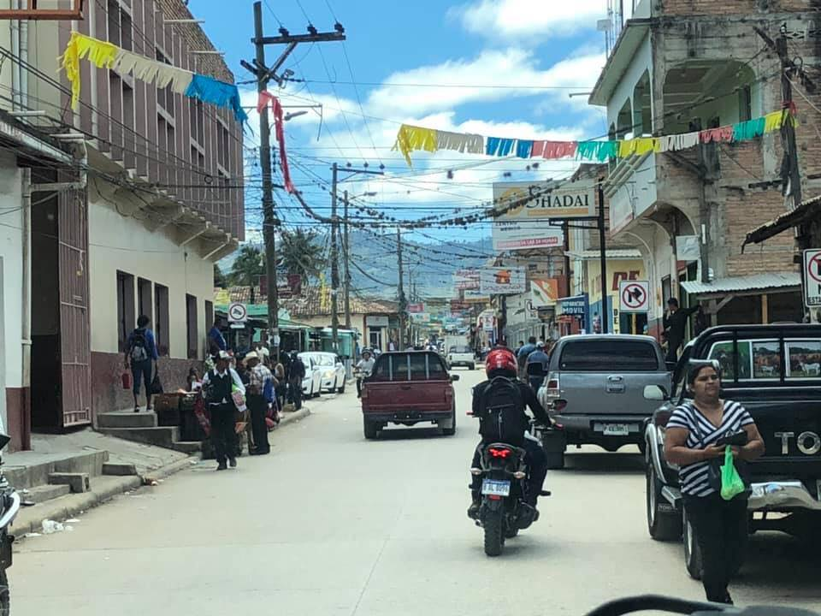
So, What Does a Scam Artist Look Like in Honduras?
This is not an all-inclusive description of a what a “Scam Artist” looks like, or the tactics they use. But it has been our experience that these are the most common methods used to manipulate and/or scam visitors.
What to be Mindful of:
- They could be men, women, or children of any age.
- They are blunt and pushy.
- They always have a pitiful story to tell you as soon as they meet you.
- They will keep asking you the same question even after you give them an answer. This tactic is a popular distraction among pickpockets!
What Should You Do?
Do not be afraid to love the people! Only be sure that if you give your resources, you are giving to people who really need it, not those who make a practice of swindling others. Feeding into these performances encourages these dishonest habits. There is only one reason why scam artist continue to press Americans for money—Because it works! These attacks can come from men, women, and children.
Displaying or counting your money in public will encourage attackers to target you. If you think someone is behaving like this towards you, seek out one of the mission leaders immediately and ask for clarity or help.
Helpful Tips:
- Never travel or adventure alone
- Never leave your items unattended
- Generally: those who are really in need are never pushy about it
Sanitation:
In Honduras, there are many different diseases and parasites that the American immune system is unequipped to fight. These diseases include malaria, bacterial diarrhea, and typhoid fever. Such disease can be contracted from several various sources.

The Most Common Areas Where Disease and Parasites Hide:
- Insects (mosquitoes and ticks)
- Untreated Honduras water
- Food and drink made with untreated Honduras water

What Should You Do?
- DO NOT eat or drink anything outside of the mission without consulting your leaders. Clean water for drinking and hygienic purpose will be provided for you
- Be careful to avoid letting water from showers or faucets touch your mouth during your regular hygiene routines
- Routinely use bug spray and hand sanitizer

We hope this guide will answer most of the usual questions you may have about your Mission’s trip to Honduras. Darrell, Darlene and Ever and Gladis will be happy to answer any other questions you may have regarding your stay here at AARONS Mission. Mail to darlenedakin1@yahoo.com . We seek to respond to all emails and personal messages within 1-3 business days. We do appreciate your support, and we look forward to serving with you as we build his kingdom together.
Darrell & Darlene Dakin
Founders
Ever and Gladis Dakin
Directors.

